FUNCTIONAL SPECIFICATIONS

Hermes Platform
Courier Services Management and Tracking Platform


AUTHOR: Document team
31/08/2026
Version 0.1.3

VERSION HISTORY
VERSION | APPROVED BY | REVISION DATE | DESCRIPTION OF CHANGE | AUTHOR
0.1.0 | Cian Goeminne | 29/08/2026 | Initial draft and first creation of document | Cian Goeminne
0.1.1 | Cian Goeminne | 31/08/2026 | Front-end Descriptions | Sandile Scwebu
0.1.2 | Cian Goeminne | 31/08/2026 | Back-end Descriptions | Jandre Burger
0.1.3 | Cian Goeminne | 31/08/2026 | Final edits and revisions of formatting | Cian Goeminne

Role | Team Member(s)
Project Manager | DS Verster, 45036349
Front-End Team | A. Ismail, 37500384 (Team lead)  S. Scwebu, 31765432  A. Aswat, 48241172
Back-End & DevOps Team | J. Burger, 40999750 (Team lead)  D. Msibi, 34854320  L. Marange, 46143823
Documentation & Quality Assurance | C Goeminne, 47799854 (Team lead)

Table of Contents
1 INTRODUCTION 4
1.1 Purpose 4
1.2 Reference Documents 4
1.3 Abbreviations and Acronyms 4
1.4 Document Conventions 4
2 GENERAL DESCRIPTION 5
2.1 Product Context 5
2.2 User Classes and Characteristics 5
2.3 Overview of Functional Requirements 6
2.4 Overview of Data Requirements 7
2.5 Operating Environment 7
2.6 General Constraints, Assumptions, Dependencies, Guidelines 7
2.7 Design and Implementation Constraints 8
2.8 User Documentation 8
3 REQUIREMENTS 9
3.1 External Interface Requirements 9
3.1.1 User Interfaces 9
3.1.2 Hardware Interfaces 9
3.1.3 Software Interfaces 10
3.1.4 Communications Interfaces 10
3.2 Functional Requirement 10
3.3 Performance Requirements 10
3.4 Security 11
3.5 Usability 11
3.6 Other Requirements 11
Appendix A. Analysis Models 12
Appendix B. Issues List 13

INTRODUCTION
The current system for the Potchefstroom campus Courier office is no longer feasible as the current process works through Microsoft SharePoint and functions completely off manual labor. The process is slowed down by slow access to previous records and the inability to calculate prices within an expeditious time. Hermes Platform looks to solve all these issues.

Purpose
This Functional Specifications Document serves as a blueprint for developing the Hermes Platform system. This document will define together with the technical specifications document the overall data needs, scope and plan while providing clear communication to all those involved.

- Shared Understanding: All stakeholders need to have a clear understanding of all features required by the system and establish the plan for what the system will do and how the system will achieve it.
- Data Management Guidance: Detailing the data the system will manage helps define storage requirements and data security considerations.
- Project Management Tool: While building the Hermes system this document will act as the main guide to help focus the attention of the development team on the overall goals of both the team and of the client.

The following sections will delve deeper into the general description of the application, its target users, and its functionalities. We'll also explore the data it will manage, the operating environment, and any constraints or assumptions. The core of the document will detail the application's requirements, including external interfaces, functional requirements, performance expectations, security measures, usability considerations, and any other relevant requirements.

Reference Documents
Feasibility study Hermes Hermes.doc
Business case – Hermes Hermes.doc
Technical specification – Hermes Hermes.doc

Abbreviations and Acronyms
Henceforth note that:
- Client refers to the Potchefstroom campus courier.
- Team refers to the entire development team including the project manager, frontend development, backend development and documentation teams.
- Application refers to the Hermes platform.
- NWU refers to Northwest University.
- OS refers to Operating system

Document Conventions
This document follows these conventions:
- Heading levels are indicated by heading styles (Heading 1, Heading 2, etc.)
- Bulleted lists are used to present sets of related items or options.
- Numbered lists are used to present sequential steps or instructions.
- When covering database aspects of the project an underscore will be used to better match the term will refer to in the actual database itself

GENERAL DESCRIPTION

Product Context
Potchefstroom campus Courier office currently receives and manages a growing volume of incoming courier packages using Microsoft SharePoint together with a largely manual administrative process.

Staff currently manually log every parcel and search for every parcel without the use of any electronic system. Total income can only be calculated through manual work of paging through all receipts that occur in a month and then adding all their totals together.

The current parcel volume already leads to lengthy admin task times and are inefficient and if the volume were to grow then the current system will go from tedious and time-consuming but functioning, all the way to no longer meeting the needs of the client or the client’s clients.

User Classes and Characteristics
The Client (Head Office)
Characteristics:
- Will use the system to perform admin work such as creating reports
- They value ease of use, organization, and accessibility.
Needs:
- Manage all staff members and their details as well as couriers
- Efficient report generation to make managerial decisions
- The ability to view and manage collection information reliably and timeously.

The client’s (Potchefstroom campus courier) staff
Characteristics:
- Employed by the client
- Will use the system to perform admin work such as handing over parcels
- They value ease of use, organization, and accessibility.
Needs:
- A user-friendly way to add and catalogue new parcels.
- Efficient search and filtering functionalities to locate specific parcels in their collection.
- The ability to view and manage collection information reliably and timeously.
The client’s clients
Characteristics:
- These are people who have hired the client to transport parcels
- They value ease of use and expeditious delivery
Needs:
- To be informed when parcels can be collected
- Collect their parcels without any major delays

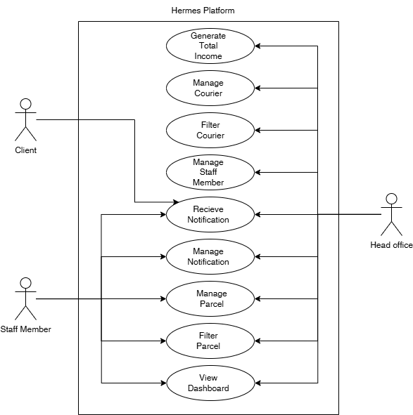

Overview of Functional Requirements
Add parcel Record:
- Users can create new entries in their collection.
- Functionality accepts inputs like recipient_name, recipient_phone, storage_location, status (whether the item has been delivered or not), etc.
- The system validates user input and stores record data in the application's database.
- A confirmation message is displayed, and the newly added record is shown in the application’s database.
Delete parcel Record:
- Functionality prompts for confirmation before deletion.
- System removes the record data from the database.

Search parcel Records:
- Users can search for specific parcels in the database using various criteria.
- Functionality allows searching by recipient_name, storage_location, parcel_type, or other relevant data points (depending on implementation).
- System searches the application’s database based on user input and displays matching records.
Send out notification:
- Once a parcel has been added to the database, an automatic notification should be sent and a record of the notification kept in the database.
Add courier record:
- Add a courier company to the list of couriers that the client works with.
Delete courier record:
- Must have the ability to remove a courier service if the client no longer works in tandem with them.
- Functionality prompts for confirmation before deletion.
- System removes the record data from the database.

User Management
Staff Registration:
- Staff members can create accounts to access and manage the application’s database.
- System validates user input, creates a new user account in the database, and logs the user in.
User Login
- Users can access their existing accounts.
- Functionality prompts for username and password.
- System validates credentials against the database and grants access to the application's database upon successful login.
User Profile Management:
- Users can view and edit their profile information.
- Functionality allows users to update details like email addresses or display names.
- System validates changes and updates the user profile information in the database.

Overview of Data Requirements
- User login credentials
- Application’s database data such as the couriers table, parcels table and notifications table

Operating Environment
The application will be developed for the windows operating system. This decision caters to the clients’ already existing technology without requiring them to upfront purchase any new costs.

General Constraints, Assumptions, Dependencies, Guidelines
Constraints:
- Project Scope: The development will prioritize core functionalities as defined in the project scope document. Additional features may be considered in future iterations based on feasibility and user feedback.
- Budget: Development will adhere to the allocated budget. This will influence decision regarding how complex the system is allowed to be such as if a barcode scanner is bought and added to the workflow
- Timeline: The application must be built within the remaining time of the NWU’s academic calendar

Assumptions:
- User Technical Literacy: Users will be able to operate the system on either their personal laptop or desktop or a client’s provided one.
- Device Compatibility: The app will target a range of laptops and desktops as well as being able to operate on multiple versions on the windows OS.
- Data Security: Users understand the importance of protecting their login credentials and the application’s data. Security measures will be implemented, but user awareness plays a role as well.

Dependencies:
- Development Tools and Libraries: The app development will rely on specific software development tools and libraries compatible with the chosen technology stack (React, Laravel, MySQL). These will be chosen based on their suitability for the functionalities and development efficiency.
- User Data Storage: The app will depend on a secure data storage solution to manage user accounts and collection information.

Guidelines:
- User Interface Design: The app will follow an easy and simple design to not overcomplicate and confuse the users of the system
- Accessibility: The app will strive to be accessible to users with disabilities, following relevant accessibility standards
- Testing and Quality Assurance: throughout the development cycle of the application, there will be thorough testing and metrics to assure the quality and service of the application.

Design and Implementation Constraints
The design and implementation of the application will adhere to the following constraints:

- Functional Scope: The core functionalities defined in the project scope will be prioritized. The core functionality will be the first aim of the project and creativity will be allowed after the core structure of the application has been created and verified as working.
- Technical Feasibility: Design decisions should consider the technical limitations of the chosen development tools and libraries.
- Performance and Scalability: Solutions must be explored to confirm that they will work on a variety of laptops and desktop and overwhelm lower end systems. Resource optimization and good coding practices must be observed
- User Interface (UI) Guidelines: The design must adhere to established GUI guidelines to create a familiar and intuitive user experience for users of the application.

Developing the system while keeping these constraints in mind will lead to a system that allows for ease of use while also assuring the quality of the application and meeting the client’s needs.

User Documentation
A user manual will be provided.

REQUIREMENTS

External Interface Requirements

User Interfaces
The application will utilize the following core UI components, designed for intuitive navigation and efficient task completion:
- Login Screen: A secure entry point for staff members to access the system. It will feature fields for username and password, with validation feedback.
- Dashboard: The main landing page after login, providing an overview of key metrics such as total parcels received, parcels ready for collection, and total collected today. It will serve as the central hub for navigation.
- Browse/Search Collection: A dedicated screen allowing staff to search and filter parcels using criteria such as tracking_number, recipient_name, courier_service, or status. Results will be displayed in a clear, sortable table.
- Add Parcel Screen: A form-based interface for logging new parcels. It will include fields for recipient_name, recipient_phone, courier_service, parcel_type, storage_location, and an optional tracking_label. This screen will support both manual entry and barcode/QR scanning input.
- View Parcel Details: A detailed view displaying all information related to a specific parcel, including its current status, history, and associated notifications. Staff can update the status (e.g., from 'Received' to 'Ready for Collection') from this screen.
- Add Courier Screen: A form to register new courier companies, capturing name, description, contact_person, phone, email, and website.
- View Courier Details: A screen displaying information about a specific courier company and a history of parcels delivered by them.
- View Notification Details: A log screen showing the history of automated notifications sent, including channel (SMS/WhatsApp), status (pending/sent/failed), and sent_at timestamp.
- View (Current) User details: A profile screen where staff can view and edit their own account information.
Navigation and Interaction:
- Navigation: The users must be able to navigate between all screens via a persistent sidebar or top navigation bar. Breadcrumbs will be provided for deep linking.
- Responsiveness: Granted that the solution is primarily designed for desktop/laptop use, the interface will be responsive enough to function on tablets if required.
- Interactivity: There should be a number of buttons as well as interactive links to take users to the respective pages to carry out their desired tasks, such as viewing parcel details or adding a new parcel to the system.
- Aesthetics: The interface should be easy to read as well as be pleasant to look at, utilizing a clean, modern design with consistent spacing and color schemes.

Hardware Interfaces
Device Compatibility: The solution needs to work efficiently over the university's present computers in the respective offices.
Operating system: The system needs to be able to work in tandem with the Windows system that is used by the client.
Barcode Scanner: The system must support input from dedicated USB/Bluetooth barcode scanners, which emulate keyboard input, to expedite the parcel logging process.
Webcam: As a fallback or alternative, the system must support webcam-based barcode/QR scanning via browser-based libraries.

Software Interfaces
Keyboard and mouse: Being that the system is meant to work over laptops as well as personal computers, the user should be able to use both to navigate the website to search for the desired parcel, update statuses, and other administrative tasks.

Communications Interfaces
Internet Access: The system will need access to the internet to carry out its functions such as allowing the users to login or request specific data, and to send SMS/WhatsApp notifications.

HTTPS: Client-server communication will use HTTPS to ensure secure data transmission.

Notifications: The system will send automated SMS messages to customers to inform them that their parcel is ready for collection.

Functional Requirement
FR1: Create and maintain parcels in Database
Create and Maintain entries in the database: Easily add new parcels, edit existing parcels, and browse all parcels in the system and find their storage locations.

FR2: Create and maintain staff members in Database
Create and Maintain entries in the database: Easily add new staff members, edit existing staff member details such as their password.

FR3: Create and maintain courier in Database
Create and Maintain entries in the database: Easily add new couriers, edit existing courier details such as their phone number or email, and browse all couriers in the system.

FR4: Automatically create notification when parcels arrive
The system should automatically send out notification to the client’s clients once their parcel has arrived at the client’s premises

FR5: Generate Income Reports
The system must be able to take all income and expenses generated within a time period and be able to generate a report that shows the total income made by the office without requiring the client to manually search through records
FR6: Role-based Authentication
Access to the system will depend on the role of the user accessing the application, permissions and actions are determined by these roles.

Performance Requirements
- Responsiveness: The app should be responsive and provide smooth user interaction. This includes minimal loading times when searching the database, adding new entries, or using other functionalities.
- Efficiency: The application should operate efficiently on a variety of laptops from both the lower end to the higher end with Windows OS and a variety of hardware specifications. Memory usage should be optimized to avoid lags or crashes.
- Offline Functionality: The core system should be able to operate offline and not require any internet connection to function

Security
- Data Security: User data, such as collection details and login credentials, should be stored securely on the device or a cloud-based storage solution using the best practices of encryption (e.g., hashing passwords with bcrypt).
- User Authentication: Proper authentication mechanisms should be in place to prevent unauthorized access, including role-based access control (RBAC) if different staff levels are required.
- POPIA Compliance: The system must handle personal information (customer names, phone numbers) in accordance with the Protection of Personal Information Act (POPIA), ensuring data is only accessible to authorized staff and retained only as long as necessary.

Usability
- Intuitive Interface: The user interface should be intuitive and easy to navigate for users with varying levels of technical expertise. Clear labeling, consistent design patterns, and user-friendly interactions are crucial.
- Task Efficiency: Users should be able to accomplish tasks within the application quickly and efficiently. This includes adding new records, searching the collection, and editing existing entries with minimal steps.
- Discoverability: Features and functionalities should be discoverable and easy to find within the application. This can be achieved through clear menus and intuitive navigation.
- Help Section: For users who aren't tech-savvy, there will be a helpful section and frequently asked questions to guide them through common issues.

Other Requirements

- Backup and Recovery: The system must include automated backup procedures to prevent data loss.
- Audit Logging: Administrator actions, such as deleting records or changing statuses, should be logged for auditing purposes.
- Analysis Models

ANALYSIS MODELS
DOCUMENT NAME | DESCRIPTION | LOCATION
HERMES_ERD.pdf | Entity Relationship Diagram showing database structure. | (GitHub)docs/Hermes ERD/HERMES_ERD.pdf
Hermes_Use_Case.pdf | Use Case Diagram showing what parts of the system different users can access | (GitHub)docs/Hermes_Use_Case/ Hermes_Use_Case.pdf

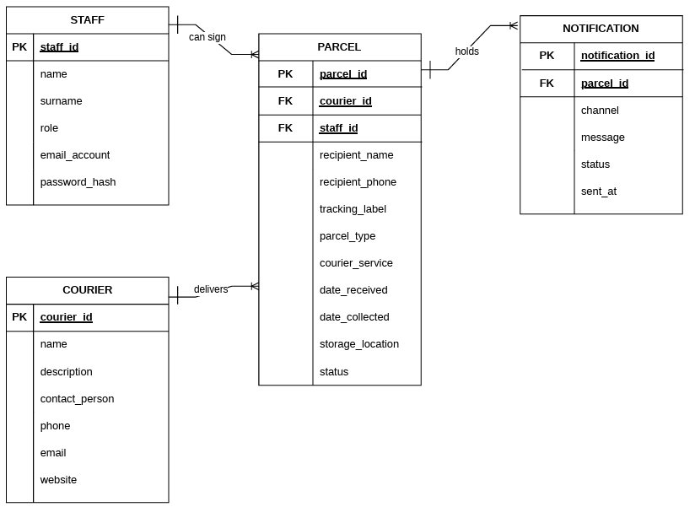

- Issues List

ISSUES LIST
ISSUE ID | ISSUE DESCRIPTION | STATUS
ISS-001 | Final confirmation of barcode scanner hardware model and compatibility. | Open
ISS-002 | Confirmation of exact flat fee amount for automated income reporting. | Open
ISS-003 | Final selection of South African bulk SMS provider and API integration details. | Open

